Validation Summary
Personal Intelligence: Real-time emotion tracker
Patent Pending: Systems and Methods for Psychological Monitoring (US 19/227,299)

Study Overview
A human-subjects validation study was conducted at Virginia Tech (IRB-approved) to evaluate the patented algorithm’s ability to predict three continuous emotional dimensions — Valence, Motivation, and Activation — from photoplethysmography (PPG) at every heartbeat.
- Design: Within-subjects, film-based emotion induction paradigm (22 min induction, ~90 min total session).
- Sample: 26 undergraduate participants (73% female; mean age 20). Screened for cardiovascular and neurological health.
- Setting: Virginia Tech Mind-Body Lab.
The design emphasized ecological emotion triggers, multi-modal physiological collection, and behavioral gold standards to ensure cross-validation of algorithm predictions.

Measures & Ground Truth
- Physiological Predictors: Finger-clip PPG (BIOPAC OXY100C); derived IBI and pulse wave amplitude (PVA). An Extended Kalman Filter (EKF) is used for frequency-domain extraction (UHF, HF, LF, VLF).
- Validation Measures:
  - Valence → Facial EMG (corrugator vs zygomatic).
  - Motivation → Continuous joystick input (approach vs avoidance).
  - Activation → Eye aspect ratio (EAR; OpenFace).

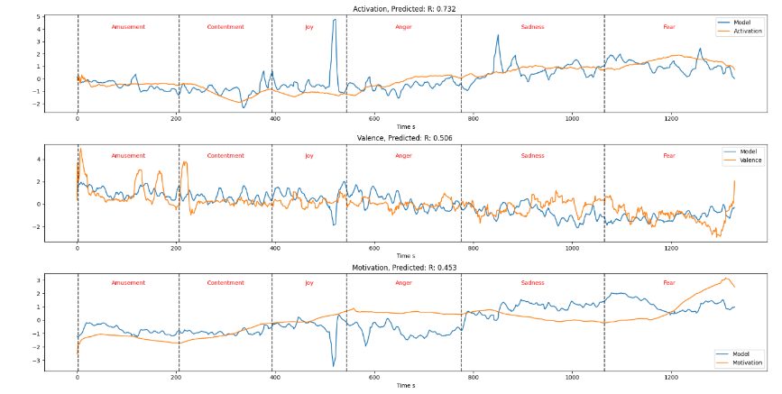
Key Results
Algorithm outputs were compared against gold-standard validators using supervised Partial Least Squares regression. Within-subjects functional data analysis (FDA) functional correlations and circular permutation tests are shown.

Full Model (PPG/IBI/PVA):
- Valence: r = .21 (L2 r = .21, p = .005, Sobolev r = .026, p = .232)
- Motivation: r = .21 (L2 r = .25, p = .003, Sobolev r = .091, p = .006)
- Activation: r = .26 (L2 r = .06, p = .343, Sobolev r = .061, p = .033)
These correlations demonstrate robust performance across all three emotional dimensions, even when restricted to IBI-only inputs, despite testing accuracy at every heartbeat.

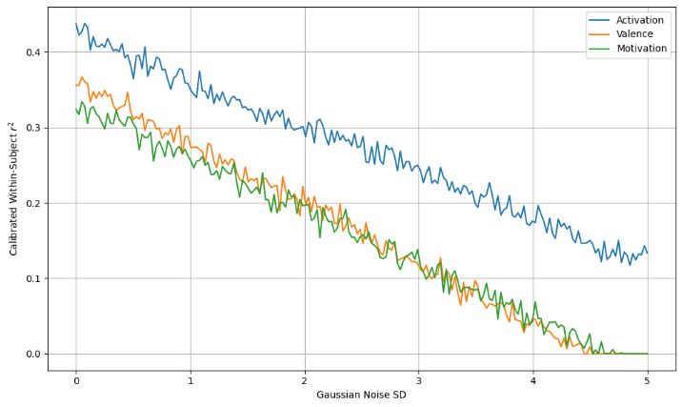
Noise Robustness
To evaluate sensitivity to noise, a robustness test against Gaussian noise was performed. Results showed that:
- r² remained above 0.3 until noise reached half a standard deviation.
- r² remained above 0.25 until noise reached a full standard deviation.
This indicates that prediction accuracy remains stable until noise is as large as the physiological signal itself. The use of multiple predictors likely aids robustness.

Limitations & Mitigations:
- PVA sensitivity: Environmental light and sensor placement may introduce noise. The implemented normalization procedures can mitigate this.
- Dropout from motion or sensor loss: Cannot be normalized, but the EKF’s time-varying modeling reduces bias from short gaps. Extremely long IBIs (>1.5–3s) can be thresholded to avoid corrupting the model (already implemented).
- Temporal resolution: Dropout lowers resolution, though EKF values can still be extracted between beats for continuity (not available in the current model).

Conclusion
The Real-Time Embedded Emotional Dimension Tracker provides validated, real-time estimation of Valence, Motivation, and Activation from wearable-class physiological signals. The method generalizes across input configurations (PPG+IBI+PVA or IBI-only) and shows strong correlations with behavioral and physiological benchmarks.
This establishes the algorithm as scientifically validated, lightweight, and ready for OEM integration.

Independent Validations
In addition to the IRB validation study, two further datasets strengthen confidence in the generalizability and irreplaceability of the patented framework:
- Event-Level Emotional Dynamics: In task-based designs (e.g., threat, outcomes, emotional faces, gratitude), the three-dimensional model tracked short-term emotional changes with significant AUC values and p-values across samples of n=40–60. These results confirm that predictions remain valid at fine temporal scales, supporting real-time applications.
Angry Face Neutral Face Happy Face
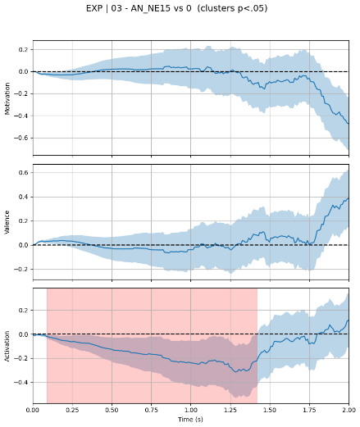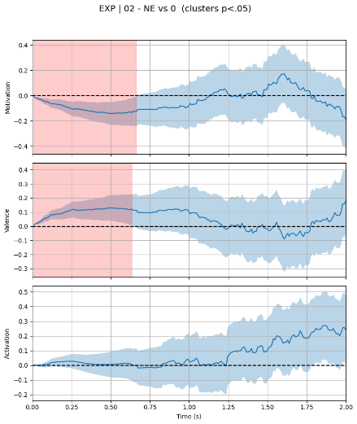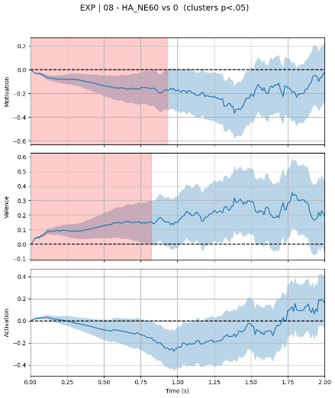
Successful prediction of task based aggressive responses 2 seconds before occurrence and a meaningful warning indicator 6 seconds before.
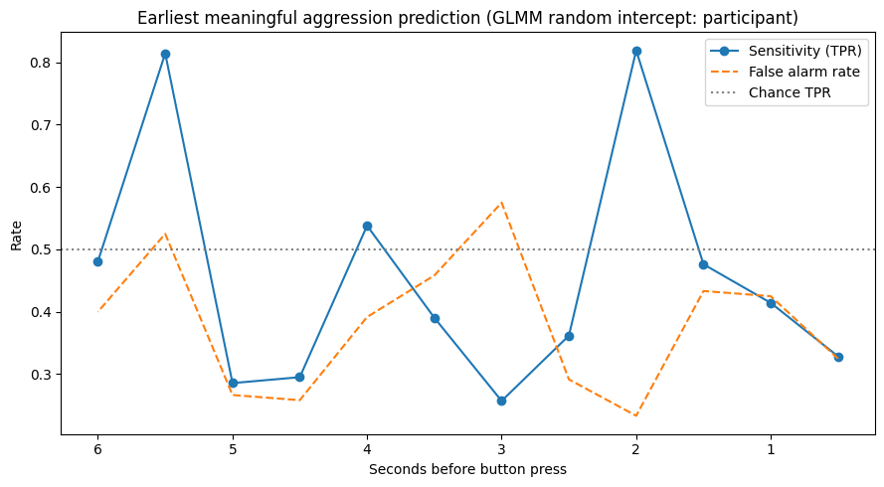
Together, these validations demonstrate that the system is not only efficient and wearable-ready but also anchored in independent neural and behavioral science. Competing approaches relying on cloud analytics or heuristic approximations cannot replicate this breadth of evidence.

-Sleep Tracking: Using the same physiology-based framework, the model was extended to predict canonical sleep stages (W, N1, N2, N3, R) from photoplethysmography and accelerometry alone. A strict leave-one-subject-out design was used to minimize bias and prevent night-specific calibration effects. Despite relying exclusively on wearable-compatible inputs, the model reliably captured transitions between sleep stages and reproduced the overall hypnogram structure across participants. Predictions showed consistent alignment with true stage onsets and offsets, particularly for major transitions such as Wake to N2, N2 to N3, and N2 to REM. While minor stages such as N1 showed reduced separability, the system recovered the temporal dynamics and architecture of sleep with high fidelity. These findings indicate that the physiological dimensions used in the emotion model, together with lightweight temporal smoothing, contain sufficient structure to support basic sleep tracking and can enhance or simplify traditional sleep staging pipelines.
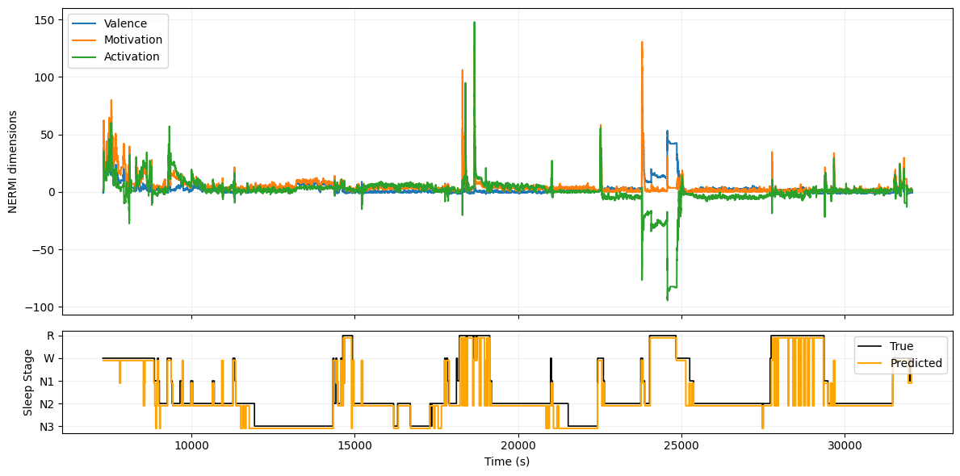
- Trait Validation: Extrinsic validation split each personality trait into two groups and applied stepwise logistic regression to extracted dimensional features, with young and older adults analyzed separately to prevent age-driven bimodality. BDI served as a benchmark, showing strong prediction in young adults (F1 = 0.79, AUC = 0.67) and moderate prediction in older adults (F1 = 0.68, AUC = 0.63), substantially outperforming RMSSD in both groups. Across remaining traits, predictive validity ranged from F1 = 0.62–0.79 in young adults and F1 = 0.64–0.81 in older adults, demonstrating robust behavioral generalizability beyond neural validation.
- fMRI Neural Validation: Across multiple analytic pipelines (TFCE maps, ROI, and age-stratified models). The three dimensions demonstrate strong, consistent, and fully dissociable brain signatures that replicate across participants and preprocessing choices. Motivation reliably engages frontostriatal and executive networks; Valence shows a distinct rightward pattern in sensory–limbic circuitry; and Activation produces robust suppression of posterior default-mode regions alongside clear salience-network modulation. These patterns remain stable in both younger and older adults, differing only in the distribution of the networks. Overall, the system delivers clean, reproducible, and biologically grounded neural correlations, validating the reliability of our real-time emotional dimensions and supporting their use in research, consumer, and clinical applications.
ROI and whole-brain analyses (hundreds of anatomically defined regions in both younger and older adults) consistently found that each emotional dimension engages a distinct, biologically grounded neurotransmitter system. Motivation showed strong positive coupling with the hypothalamus, extended amygdala, and dorsal striatum, forming the core mesolimbic dopaminergic and opioid-supported drive system. Valence, in contrast, produced coherent negative effects in the PAG, midbrain reticular nuclei, right insula, ACC, and dorsal striatum. Precisely the regions innervated by serotonergic mood-regulation pathways and by the nigrostriatal dopamine system, which handles aversive prediction, cost evaluation, and sensory–motor emotional tone. Activation generated widespread, FDR-significant suppression across insula, ACC, amygdala, basal ganglia, and midbrain arousal structures (with locus coeruleus trends), forming a clear norepinephrine-linked arousal signature that downshifts slower dopaminergic and opioid systems during high autonomic demand. The results provide strong convergent evidence that the three dimensions reflect separable physiological systems rooted in distinct monoaminergic circuits, not statistical artifacts.

Motivation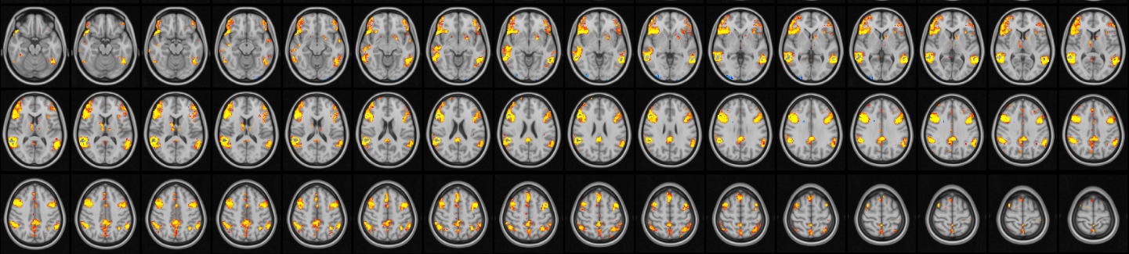

Valence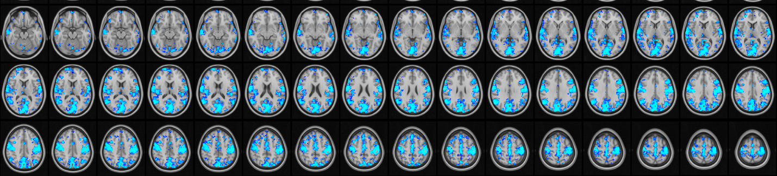

Activation
